Sandown Town Council Installs New Public Water Fountain to Help Reduce Plastic Waste
Sandown, Isle of Wight – Sandown Town Council is pleased to announce the installation of a new public water fountain and bottle filling station in Eastern Gardens, adjacent to the Changing Places facility, providing residents and visitors with free access to drinking water while helping to reduce the use of single-use plastic bottles.
The project supports efforts to protect the coastal and marine environment by encouraging the use of reusable water bottles and reducing plastic litter that can find its way into the sea. Located within easy reach of Sandown's popular seafront, Eastern Gardens, the fountain is ideally positioned for beach users, walkers, cyclists, families and tourists visiting the town.
The installation aligns closely with the aims of the Sea-Changers Coastal Fountain Fund, which supports projects that help prevent marine litter and reduce the negative impacts of plastic waste on coastal habitats and wildlife. The fund, supported by Bunzl plc, provides funding towards the purchase of water fountain units at publicly accessible coastal locations across the UK.
The new fountain in Eastern Gardens has been placed in a highly visible and accessible location close to the beachfront, where it is expected to receive significant public use throughout the year and particularly during the busy summer season. By providing a convenient refill point, Sandown Town Council hopes to encourage more people to carry reusable bottles and make sustainable choices when enjoying the town's seafront.
A spokesperson for Sandown Town Council said:
"The Council is committed to improving facilities for residents and visitors while taking practical steps to protect our coastal environment. The new water fountain in Eastern Gardens provides free drinking water in a convenient location and will help reduce reliance on single-use plastic bottles. We are delighted to support initiatives that promote sustainability and help keep our beaches and public spaces free from litter."
The Council has ensured that appropriate arrangements are in place for the ongoing maintenance of the fountain, helping to secure its long-term use and benefit to the community.
The fountain's location next to the Changing Places facility further enhances accessibility, ensuring that a wider range of residents and visitors can benefit from this important public amenity.
Sandown Town Council encourages everyone using the seafront and surrounding areas to bring a reusable water bottle and make use of the new facility.
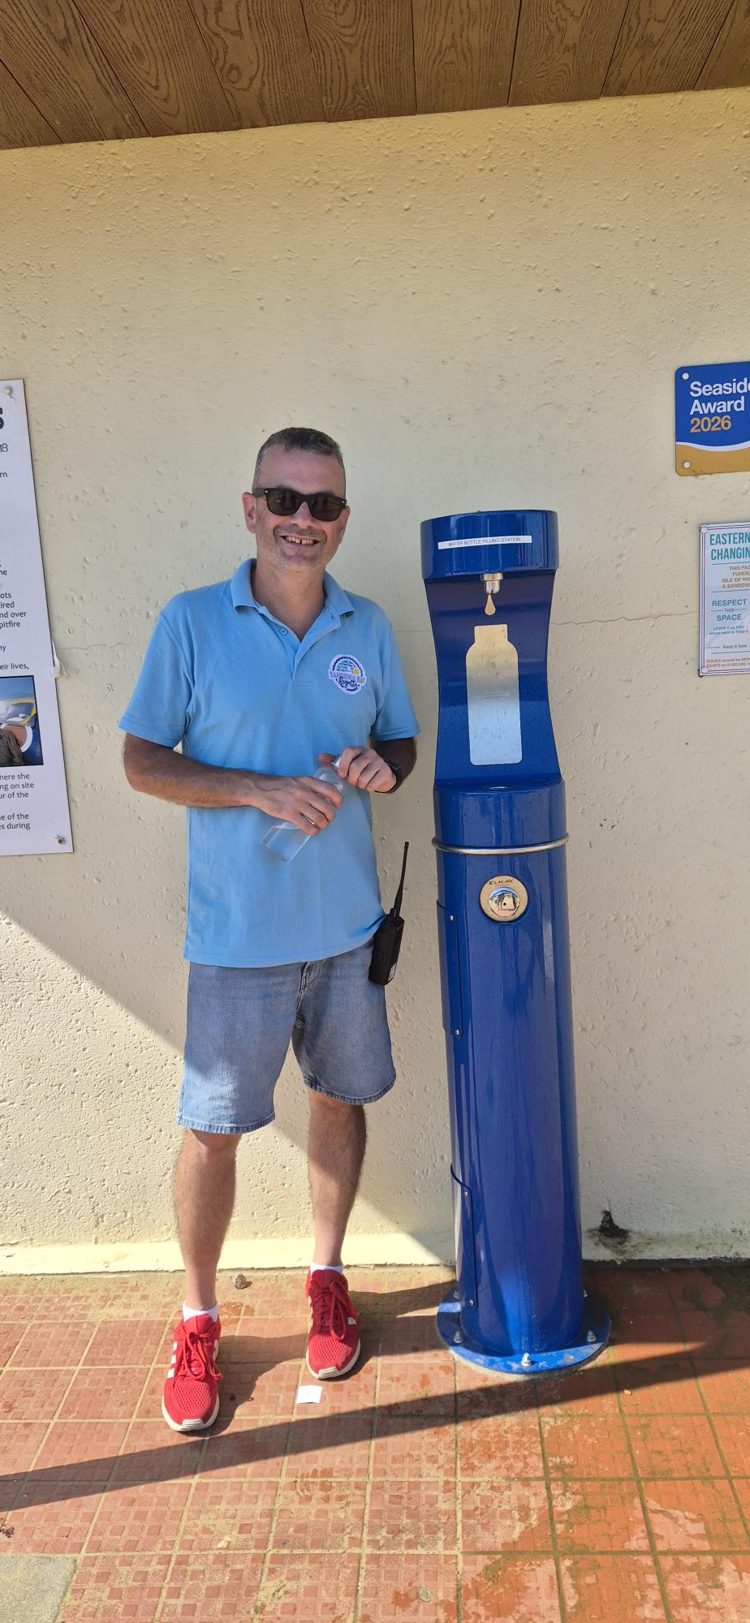

Website: www.sandowntowncouncil.gov.uk
